**PHARMACY MANAGEMENT SYSTEM**

A Dissertation submitted in

partial fulfilment of the requirement for the award of Degree of

**MASTER IN INFORMATION TECHNOLOGY**

Submitted By

**SAQIB AHMED. O**

(**Register No**: 31918P19004)

Under the guidance of

Prof. **P. Rizwan Ahmed**, M.C.A., M.Sc., M.A., M.Phil., Ph.D.



A project submitted to

**P.G Department of Information Technology.**

**Mazharul Uloom College**

**AMBUR – 635802**

**March – 2020**

**ACKNOWLEDGEMENT**

First and Foremost, I express my gratitude to Almighty whose blessing upon me, and his grace cover all the time to complete my projects. I would like to thanks my parents whose endless supports and encouraging made my projects a bit lighter.

I would like to thanks **Dr. M. Mohammad Yunus** , M.Sc, Ph.D., the principal of the Mazharul Uloom College, Ambur for kind support to allow projects completion.

I express a sincere gratitude to **Dr. P. Rizwan Ahmed**, M.C.A., M.Sc., M.A., M.Phil., Ph.D. the Head of the Department of Information Technology, Mazharul Uloom College, Ambur for the endless support and guide to share the valuable ideas in completion of the projects

I would like to thanks all our staff member of the Department of Information Technology, Mazharul Uloom College, Ambur for their valuable support and guidance at the proper time and encouraging me to choosing a correct projects in recent technology and share their resource and ideas in completion of project.

Last but not least, I would like to thank all of my friends for their valuable support and comments.



**CERTIFICATE**

This is to certify that the projects titled ”**PHARMACY MANAGEMENT SYSTEM** ” is Bonafide and work done by

**SAQIB AHMED. O**

(Register No: 31918P19004)

In partial fulfilment of the requirement for the award of “ **M.Sc in Information Technology**”.

Signature of the Guide Head of the Department

(Prof. P. Rizwan Ahmed)

The viva-voce examination of this projects is held on ________________

**External**

1.

2.

**CONTENTS**

|  |  |  |
| --- | --- | --- |
| **No** | **Title** | **Page No** |
| 1 | Introduction | 06 |
| 2 | System Analysis | 07 |
| 3 | System Configuration   * Hardware Requirement * Software Requirement | 08 |
| 4 | System Design   * Architectural Design * Context level Design * Dataflow Design * Database Design | 09 |
| 5 | Project Description | 16 |
| 6 | Software Testing   * Black Box Testing * White Box Testing * System Testing * Unit Testing | 18 |
| 7 | Source Code | 20 |
| 8 | Screen Shot | 48 |
| 9 | Conclusion | 55 |
| 10 | References & Bibliography | 56 |

**ABSTRACT**

In this projects, I am doing a Pharmacy management system. It provide a pharmacy owner to keep tracks of medicine present in the store. The pharmacy owner can add, update , delete the record of information .He/She can also search a particular records on the basis of medicine name, thus it will give the complete information of the medicine which include the batch of medicine name, thus it will give the complete information of the medicine. Anyone can find the details of stock, purchase and sales. This system is user friendly and cost effective. This is design to flexible and easily adaptable for pharmacy’s need.

**INTRODUCTION**

The purpose of this Pharmacy Management System project is to improve the maintenance and manipulation of the drugs in the medicals. The pharmacy management system will be used to minimize the time and resource by maintaining the details of the drug systemically so that the data can be used in possible quickest time. While the resource which is minimized are workforce, money, papers, etc. The system is user-friendly and will help the pharmacist. This Pharmacy Management System will reduce the burden on pharmacist and will make the system efficient by providing the more accurate details about drugs in the medical.

**EXISTING SYSTEM**

Currently, the medical works are based on the manual process, and each work is maintained in the paper. The details of purchasing drugs, audits, sell reports maintained on the paper while anyone can enter into the system and can make changes in these reports, so it is not a safe method to keep the information on the paper. The pharmacist faces problem in searching the products from the self as it is not an easy method to remember about the place of each medicine. There no Pharmacy Management System which can alert the pharmacist about the end of the drugs.

**PROPOSED SYSTEM**

The design of the pharmacy management system is based on the computer which will simplify the maintenance of the information, accessible and efficient. The Pharmacy Management System will provide the information about the end of the drugs in the medical so that the physician can order them drugs before the end. The pharmacist and nurses will get more accurate results at the time sell, about the details of the use of medicines and the dosages so that the system will become more reliable to use than the present system. The records of each work will be secure as to access the information the user must have to provide the ID and password in the system.

**SYSTEM CONFIGURATIONS:**

**Hardware Requirements:**

Processor : Intel dual core processor

RAM : Minimum 2 GB

Monitor : 15” Colour Monitor

Hard disk : Minimum 40 GB

Input device : 104 keys keyboard, optic mouse.

**Software Requirements:**

Operating System : Windows 7, 8, 10

Front-End : JSP Technology

Back-End : MySQL

Scripting : JavaScript, JQuery

Server : Apache Tomcat 7.0

**SYSTEM DESIGN:**

**Architectural Diagram:**

Admin Login:

ADMIN

Pharmacy Management System

Unauthorized

Customer Login:

Customer

Unauthorized

Database

Authorized

Pharmacy Management System

**Context Level Diagram:**

Admin Page:

Customer Page:

**Level One Diagram:**

Bill to Customer

Products Information

Order products

Sale products

Supply products

Order products

Supply products

Order products

**Dataflow Diagram:**

Admin:

ADMIN

Login

Condition

Purchase

Products

Supplier

Customer

View order

Log out

Customer:

Customer

Login

Condition

About Us

Orders

Products Search

Log out

**Database design:**

**Table Name:** Register

|  |  |  |  |
| --- | --- | --- | --- |
| Name | Constraints | Type | Size |
| Customer_ID | Primary Key | Integer | 6 |
| Customer_Name |  | Varchar | 25 |
| Username |  | Varchar | 25 |
| Password |  | Varchar | 25 |
| Address |  | Varchar | 40 |
| Mobile |  | Varchar | 10 |

**Table Name:** Products

|  |  |  |  |
| --- | --- | --- | --- |
| Name | Constraints | Type | Size |
| Product_Name |  | Varchar | 25 |
| Company_Name |  | Varchar | 25 |
| Manufacture date |  | Date | 10 |
| Expiry Date |  | Date | 10 |
| Price |  | Double | 10 |

**Table Name**: Billing

|  |  |  |  |
| --- | --- | --- | --- |
| Name | Constraints | Type | Size |
| Bill_No |  | Varchar | 25 |
| Bill_Date |  | Date | 10 |
| Product_Name |  | Varchar | 25 |
| Quantity |  | Numeric | 5 |
| Price |  | Numeric | 6 |
| Discount |  | Varchar | 5 |
| GST |  | Integer | 5 |
| Amount |  | Numeric | 10 |

**Table Name :** Orders

|  |  |  |  |
| --- | --- | --- | --- |
| Name | Constraints | Type | Size |
| Order_no |  | Varchar | 10 |
| Order_date |  | Date | 10 |
| Product_Name |  | Varchar | 25 |
| Quantity |  | Numeric | 5 |

**Table Name**: Supplier

|  |  |  |  |
| --- | --- | --- | --- |
| Name | Constraints | Type | Size |
| Supplier_id | Primary Key | Varchar | 6 |
| Supplier_Name |  | Varchar | 25 |
| Address |  | Varchar | 40 |
| Mobile |  | Varchar | 15 |
| GST |  | Varchar | 15 |

**Table Name:** Purchase

|  |  |  |  |
| --- | --- | --- | --- |
| Name | Constraints | Type | Size |
| Bill_No |  | Varchar | 5 |
| Bill_Date |  | Date | 10 |
| Supplier_ID |  | Varchar | 10 |
| Product_Name |  | Varchar | 25 |
| Company_Name |  | Varchar | 25 |
| Quantity |  | Varchar | 5 |
| Price |  | Numeric | 10 |
| GST |  | Integer | 5 |
| Total |  | Numeric | 10 |

**PROJECT DESCRIPTION**

**Problem Definition:**

The Owner of the pharmacy needs to maintain the products details in notebooks. They need to search for the products manually . Whether the products need to buy or not. Not available of the quantity of the stock. Need to Bills manually for the sale of the products medicine. To avoid these kind of problems we are making it as system wise billing mechanism. The Expiry date of the each products is cannot be maintain manually. This can be achieved with the help of the system.

**Module Description:**

* Administrator
* Medicine Search
* Medicine Information
* Purchase information
* Sale Information
* Order of the Medicine.

**Administrator**

The Admin Module provide the information about the administrator of the pharmacy module including every cover of the pharmacy.

**Medicine Search:**

This module provide and give access to the customer to search for the products currently available or not in the store.

**Medicine Information:**

The Medicine information module providing information about Medicine products and its information like manufacturing date and expiry date and the price of the products.

**Purchase Information:**

The Purchase Information module provide the purchase of the medicine products and stocks of the products.

**Sale Information:**

The Sale Information module provide the sale list of the products and Billing of the medicine being sale.

**Order Medicine:**

The Order module is for the customer that provide and access to order the medicine products from the pharmacy. A customer can order medicine and receipt can be send against the order.

**SYSTEM TESTING**

**Introduction**

Software testing is an investigation conducted t provide stakeholders with information about the quality of the product or service under test. Software testing can also provide an objective, independent view of the software to allow the business to appreciate and understand the risk of software implementation. Test techniques include the process of executing a process of executing a program or application with the intent of finding software bugs(errors or other defects). It involve the execution of a software component or system to evaluate one or more properties of interest.

**Black Box Testing:**

Black Box Testing is a software testing method which is used to test the software without knowing the internal structure of code or program. The main purpose of the Black Box is to check whether the software is working as per expected in requirement document and whether it meet the user expectation or not. Tester only passes valid as well as invalid input and determine the correct expected outputs. All the test using such methods are calculate based on requirement and specification.

**White Box Testing:**

White Box testing is also known as Code based Testing or Structural Testing. White Box testing is the software testing method in which internal structure is being known to tester who is going to test the application. Testing Based on analysis of the internal structure of the component or system. While unit, integration and system levels of the software testing process, it is usually done at the unit level. It can test path with a unit, path between units during integration, between subsystem during a system-level test.

**System Testing:**

System Testing or end-to-end testing is a completely integrated system to verify that it meets its requirement, For Example, a system test involve the testing a logon interface, then creating and editing an entry , plus sending or printing results, followed by summary processing or deletion of entries, then logoff. In addition to , application testing . It ensure that the program , as well as working expected, does not also destroy or partially corrupt its operating environment or cause other processes within that environment to become inoperative or not consuming or locking up excessive resource and parallel process unarmed by its presence.

**Unit Testing:**

Unit testing is software development process that involves synchronized application of a broad spectrum of defect prevention and detection strategies in order to reduce software development risk , time , cost. It is performed by the software developer or engineer during the construction phase of the development cycle, rather the replace the traditional QA focus and it arguments.

**Overview:**

Function test provide systematic demonstration that function tested are available as specified by the business and technical requirements, System documentation and user manuals. Functional testing is centered on the following items.

Valid Input : identified classes of valid input must be accepted.

Invalid Input: identified classed of invalid must be rejected.

Functions: identified functions must be exercised.

Output: identified classes of application output must be exercised.

System/procedure : Interfacing system or procedure must be invoked.

**SOURCE CODE**

**Index Page:**

<!DOCTYPE html PUBLIC "-//W3C//DTD HTML 4.01 Transitional//EN" "http://www.w3.org/TR/html4/loose.dtd">

<html>

<head>

<meta http-equiv=*"Content-Type"* content=*"text/html; charset=ISO-8859-1"*>

<title>Pharmacy Management System</title>

<link type=*"text/css"* rel=*"stylesheet"* href=*"mycss.css"*/>

</head>

<body>

<div class=*"header"*>

<img alt=*""* src=*"img/logo.jpg"*>

<h1>Pharmacy Management System</h1>

</div>

<div class=*"navbar"*>

<a href=*"loginprocess.jsp"* class=*"right"*>Login</a>

</div>

<div class=*"container"*>

<div class=*"myslide"*><img src=*"img/img1.jpg"* style="width:*100%*" /></div>

<div class=*"myslide"*><img src=*"img/img2.jpg"* style="width:*100%*" /></div>

<div class=*"myslide"*><img src=*"img/img3.jpg"* style="width:*100%*" /></div>

<div class=*"myslide"*><img src=*"img/img4.jpg"* style="width:*100%*" /></div>

</div>

<script type=*"text/javascript"*>

**var** slideIndex = 0;

showSlides();

**function** showSlides() {

**var** i;

**var** slides = document.getElementsByClassName("myslide");

**for** (i = 0; i < slides.length; i++) {

slides[i].style.display = "none";

}

slideIndex++;

**if** (slideIndex > slides.length) {slideIndex = 1}

slides[slideIndex-1].style.display = "block";

setTimeout(showSlides, 2000); // Change image every 2 seconds

}

</script>

</body>

</html>

**Login Processing Page:**

<%@ page language="java" contentType="text/html; charset=ISO-8859-1"

pageEncoding="ISO-8859-1"%>

<!DOCTYPE html PUBLIC "-//W3C//DTD HTML 4.01 Transitional//EN" "http://www.w3.org/TR/html4/loose.dtd">

<html>

<head>

<meta http-equiv="Content-Type" content="text/html; charset=ISO-8859-1">

<title>Login</title>

<style type="text/css">

form {

border: 3px solid #f1f1f1;

}

/* Full-width inputs */

input[type=text], input[type=password] {

width: 100%;

padding: 12px 20px;

margin: 8px 0;

display: inline-block;

border: 1px solid #ccc;

box-sizing: border-box;

}

/* type of login*/

select{

width:80%%;

padding:12px 20px;

margin:8px 0;

display:inline-block;

border: 1px solid #ccc;

box-sizing: border-box;

}

/* style for all buttons */

button {

background-color: #4CAF50;

color: white;

padding: 14px 20px;

margin: 8px 0;

border: none;

cursor: pointer;

width: 80%;

}

button:hover {

opacity: 0.8;

}

.cancelbtn {

width:80%;

padding: 10px 18px;

background-color: #f44336;

}

.imgcontainer {

text-align: center;

margin: 24px 0 8px 0;

}

img.avatar {

width: 20%;

border-radius: 50%;

}

.container {

padding: 12px;

}

span.psw {

float: right;

padding-top: 16px;

}

</style>

</head>

<body>

<form action="Mainpage.jsp" method="post" >

<div class="imgcontainer">

<img src="img/avat.png" alt="Avatar" class="avatar">

</div>

<div class="container">

<%

if(request.getAttribute("check")!=null){

out.println("<b style='color:red;'>"+request.getAttribute("check")+"</b><br>");

}

%>

<%

if(request.getAttribute("reg")!=null){

out.println("<b style='color:blue;'>"+request.getAttribute("reg")+"</b><br>");

}

%>

<label for="uname"><b>Username</b></label><br>

<input type="text" placeholder="Enter Username" name="uname" required>

<label for="psw"><b>Password</b></label><br>

<input type="password" placeholder="Enter Password" name="psw" required>

<label for="type"><b>Type</b></label><br>

<select name="utype" style="width:100%">

<option value="Admin">Administrator</option>

<option value="customer">Customer</option>

</select><br>

<center>

<button type="submit">Login</button></center>

<br><br>

<a href="Register.jsp">Sign Up Here</a>

</div>

</form>

</body>

</html>

**Register :**

<%@ page language="java" contentType="text/html; charset=ISO-8859-1"

pageEncoding="ISO-8859-1"%>

<!DOCTYPE html PUBLIC "-//W3C//DTD HTML 4.01 Transitional//EN" "http://www.w3.org/TR/html4/loose.dtd">

<html>

<head>

<meta http-equiv="Content-Type" content="text/html; charset=ISO-8859-1">

<title>Pharmacy Management System</title>

<style type="text/css">

* {

box-sizing: border-box;

}

body {

font-family: Arial, Helvetica, sans-serif;

margin: 0;

}

.header {

padding: 80px;

text-align: center;

background: #4cf051;

color: white;

}

.header h1 {

font-size: 40px;

}

</style>

</head>

<body>

<div class="header">

<img alt="" src="img/logo.jpg">

<h1>Pharmacy Mangement System</h1>

</div>

<center> Registration Form</center>

<form action="registerprocess.jsp">

<table cellpadding="5" cellspacing="5">

<tr>

<td></td><td></td>

</tr>

<tr>

<td>Customer ID: </td><td><input type="text" name="custid"/></td>

</tr>

<tr>

<td>Customer Name: </td><td><input type="text" name="custname"/></td>

</tr>

<tr>

<td>Username: </td><td><input type="text" name="uname"/></td>

</tr>

<tr>

<td>Password: </td><td><input type="password" name="psw"/></td>

</tr>

<tr>

<td>Address: </td><td><input type="text" name="custadd"/></td>

</tr>

<tr>

<td>Mobile: </td><td><input type="text" name="custmobile"/></td>

</tr>

<tr>

<td></td><td><input type="submit" style="padding:10px;" value="Register"/></td><td><input type="reset" style="padding:10px;" value="Cancel"/></td>

</tr>

</table></form>

&nbsp;&nbsp;&nbsp;

<a href="loginprocess.jsp">Back</a>

</body>

</html>

**Register Processing:**

<%@ page import="com.pharmacy.*,java.sql.*" %>

<%@ page language="java" contentType="text/html; charset=ISO-8859-1"

pageEncoding="ISO-8859-1"%>

<!DOCTYPE html PUBLIC "-//W3C//DTD HTML 4.01 Transitional//EN" "http://www.w3.org/TR/html4/loose.dtd">

<html>

<head>

<meta http-equiv="Content-Type" content="text/html; charset=ISO-8859-1">

<title>Insert title here</title>

</head>

<body>

<jsp:useBean id="u" class="com.pharmacy.Register"></jsp:useBean>

<jsp:setProperty property="*" name="u"/>

<%

int i=LoginDao.save(u);

if(i>0){

out.println("Record save Succefully");

request.setAttribute("reg", "Records Save Succesfully");

response.sendRedirect("loginprocess.jsp");

}else{

response.sendRedirect("Errorpage.jsp");

}

%>

</body>

</html>

**LoginDao.java:**

package com.pharmacy;

import java.sql.Connection;

import java.sql.DriverManager;

import java.sql.PreparedStatement;

import java.sql.ResultSet;

import java.util.ArrayList;

import java.util.List;

public class LoginDao {

public static Connection con=null;

public static Connection getconnect(){

try{

Class.forName("com.mysql.jdbc.Driver");

con=DriverManager.getConnection("jdbc:mysql://localhost:3306/pharmacy","root","");

}catch (Exception e) {

// TODO: handle exception

e.printStackTrace();

}

return con;

}

public static int save(Register u){

int status=0;

try{

Connection con = getconnect();

PreparedStatement ps= con.prepareStatement("insert into register(custid,custname,uname,psw,address,mobile)values(?,?,?,?,?,?)");

ps.setInt(1, u.getCustid());

ps.setString(2, u.getCustname());

ps.setString(3, u.getUname());

ps.setString(4, u.getPsw());

ps.setString(5, u.getCustadd());

ps.setString(6, u.getCustmobile());

status=ps.executeUpdate();

}catch (Exception e) {

e.printStackTrace();

}

return status;

}

public static int delete(Register u){

int status=0;

try{

Connection con =getconnect();

PreparedStatement ps=con.prepareStatement("delete from Register where custid=?");

ps.setInt(1, u.getCustid());

status=ps.executeUpdate();

}catch (Exception e) {

e.printStackTrace();

}

return status;

}

public static List<Register> getAllrecords(){

List<Register> list= new ArrayList<Register>();

try{

Connection con=getconnect();

PreparedStatement ps=con.prepareStatement("select * from register");

ResultSet rs=ps.executeQuery();

while(rs.next()){

Register u= new Register();

u.setCustid(rs.getInt(1));

u.setCustname(rs.getString(2));

u.setCustadd(rs.getString(5));

u.setCustmobile(rs.getString(6));

list.add(u);

}

}catch (Exception e) {

e.printStackTrace();

}

return list;

}

}

**Register Bean:**

package com.pharmacy;

public class Register {

int custid;

String custname;

String uname;

String psw;

String custadd;

String custmobile;

/**

* @return the custid

*/

public int getCustid() {

return custid;

}

/**

* @param custid the custid to set

*/

public void setCustid(int custid) {

this.custid = custid;

}

/**

* @return the custname

*/

public String getCustname() {

return custname;

}

/**

* @param custname the custname to set

*/

public void setCustname(String custname) {

this.custname = custname;

}

/**

* @return the uname

*/

public String getUname() {

return uname;

}

/**

* @param uname the uname to set

*/

public void setUname(String uname) {

this.uname = uname;

}

/**

* @return the psw

*/

public String getPsw() {

return psw;

}

/**

* @param psw the psw to set

*/

public void setPsw(String psw) {

this.psw = psw; }

/**

* @return the custadd

*/

public String getCustadd() {

return custadd;

}

/**

* @param custadd the custadd to set

*/

public void setCustadd(String custadd) {

this.custadd = custadd;

}

/**

* @return the custmobile

*/

public String getCustmobile() {

return custmobile;

}

/**

* @param custmobile the custmobile to set

*/

public void setCustmobile(String custmobile) {

this.custmobile = custmobile;

}

}

**Processing login page :**

<%@page import="com.pharmacy.*"%>

<%@ page language="java" import="java.sql.*" contentType="text/html; charset=ISO-8859-1"

pageEncoding="ISO-8859-1"%>

<!DOCTYPE html PUBLIC "-//W3C//DTD HTML 4.01 Transitional//EN" "http://www.w3.org/TR/html4/loose.dtd">

<html>

<head>

<meta http-equiv="Content-Type" content="text/html; charset=ISO-8859-1">

<title>Pharmacy Mangement System</title>

</head>

<body>

<%@include file="header.html" %>

<jsp:useBean id="u" class="com.pharmacy.Register"></jsp:useBean>

<jsp:setProperty property="*" name="u"/>

<%

String username=request.getParameter("uname");

String pass= request.getParameter("psw");

String utype=request.getParameter("utype");

if(utype.equals("Admin")){

if(username.equals("Admin") && pass.equals("admin@123"))

{

session.setAttribute("username", username);

response.sendRedirect("adminmain.jsp");

}

else{

request.setAttribute("check", "Invalid username and password");

%>

<jsp:forward page="loginprocess.jsp"></jsp:forward>

<%

}

}else if(utype.equals("customer")){

try{

Connection con=null;

con = LoginDao.getconnect();

Statement st=con.createStatement();

ResultSet rs=st.executeQuery("select * from register;");

while(rs.next()){

if(username.equals(rs.getString(3)) && pass.equals(rs.getString(4)))

{

session.setAttribute("uname", username); %>

<jsp:forward page="custmain.jsp"></jsp:forward> <%

}

}

request.setAttribute("check", "Pls entered correct Password<br>");

%> <jsp:forward page="loginprocess.jsp"></jsp:forward> <%

}catch(Exception e){

e.printStackTrace();

}

}

%>

</body>

</html>

**Admin MainPage :**

<%@ page language="java" contentType="text/html; charset=ISO-8859-1"

pageEncoding="ISO-8859-1"%>

<!DOCTYPE html PUBLIC "-//W3C//DTD HTML 4.01 Transitional//EN" "http://www.w3.org/TR/html4/loose.dtd">

<html>

<head>

<meta http-equiv="Content-Type" content="text/html; charset=ISO-8859-1">

<title>Pharmacy Management System</title>

<style type="text/css">

.box{

width:200px;

height:120px;

background-color: #4cf051;

color:white;

font-size:18px;

text-align: center;

padding:20px;

margin :20px;

}

.container{

display: flex;

justify-content:center;

}

</style>

</head>

<body>

<%@ include file="header.html" %>

<%

if(session.equals(null)){

session.invalidate();

}else{

String uname= (String)session.getAttribute("username");

out.println("<center><h1> Welcome "+ uname+"</h1><center>");

session.invalidate();

}

%>

</body>

</html>

**Admin Header.html:**

<!DOCTYPE html PUBLIC "-//W3C//DTD HTML 4.01 Transitional//EN" "http://www.w3.org/TR/html4/loose.dtd">

<html>

<head>

<meta charset="UTF-8">

<meta name="viewport" content="width=device-width, initial-scale=1">

<title></title>

<style type="text/css">

* {

box-sizing: border-box;

}

body {

font-family: Arial, Helvetica, sans-serif;

margin: 0;

}

.header {

padding: 20px;

text-align: center;

background: #4cf051;

color: white;

}

.header h1 {

font-size: 30px;

}

.navbar {

overflow: hidden;

background-color: #333;

}

.navbar a {

float: left;

display: block;

color: white;

text-align: center;

padding: 14px 20px;

text-decoration: none;

}

.navbar a.right {

float: right;

}

.navbar a:hover {

background-color: #ddd;

color: black;

}

</style>

</head>

<body>

<div class="header">

<img alt="" src="img/logo.jpg">

<h1>Pharmacy Mangement System</h1>

</div>

<div class="navbar">

<a href="adminmain.jsp">Home</a>

<a href="Products.jsp">Products</a>

<a href="Purchase.jsp">Purchase</a>

<a href="Supplier.jsp">Supplier</a>

<a href="Billing.jsp">Billing</a>

<a href="Customer.jsp">View Customer</a>

<a href="vieworder.jsp">View Order</a>

<a href="loginprocess.jsp" class="right">Log Out</a>

</div>

</body>

</html>

**Customer.html:**

<!DOCTYPE html PUBLIC "-//W3C//DTD HTML 4.01 Transitional//EN" "http://www.w3.org/TR/html4/loose.dtd">

<html>

<head>

<meta charset="UTF-8">

<meta name="viewport" content="width=device-width, initial-scale=1">

<title></title>

<style type="text/css">

* {

box-sizing: border-box;

}

body {

font-family: Arial, Helvetica, sans-serif;

margin: 0;

}

.header {

padding: 80px;

text-align: center;

background: #4cf051;

color: white;

}

.header h1 {

font-size: 40px;

}

.navbar {

overflow: hidden;

background-color: #333;

}

.navbar a {

float: left;

display: block;

color: white;

text-align: center;

padding: 14px 20px;

text-decoration: none;

}

.navbar a:hover {

background-color: #ddd;

color: black;

}

.navbar a.right {

float: right;

}

</style>

</head>

<body>

<div class="header">

<img alt="" src="img/logo.jpg">

<h1>Pharmacy Mangement System</h1>

</div>

<div class="navbar">

<a href="custmain.jsp">Home</a>

<a href="Order.jsp">Order</a>

<a href="productsearch.jsp">Search</a>

<a href="Aboutus.jsp">About Us</a>

<a href="loginprocess.jsp" class="right">Log Out</a>

</div>

</body>

</html>

**Mycss Style File:**

@CHARSET "ISO-8859-1";

* {

box-sizing: border-box;

}

body {

font-family: Arial, Helvetica, sans-serif;

margin: 0;

}

.header {

padding: 80px;

text-align: center;

background: #4cf051;

color: white;

}

.header h1 {

font-size: 40px;

}

.navbar {

overflow: hidden;

background-color: #333;

}

.navbar a {

float: left;

display: block;

color: white;

text-align: center;

padding: 14px 20px;

text-decoration: none;

}

.navbar a.right {

float: right;

}

.navbar a:hover {

background-color: #ddd;

color: black;

}

.container{

max-width: 1000px;

max-height:700px;

position: relative;

margin: auto;

}

.myslide{

display: none;

}

**Error Page:**

<%@ page language="java" errorPage="true" contentType="text/html; charset=ISO-8859-1"

pageEncoding="ISO-8859-1"%>

<!DOCTYPE html PUBLIC "-//W3C//DTD HTML 4.01 Transitional//EN" "http://www.w3.org/TR/html4/loose.dtd">

<html>

<head>

<meta http-equiv="Content-Type" content="text/html; charset=ISO-8859-1">

<title>Pharmacy Management System</title>

</head>

<body>

OOps Error.!

</body>

</html>

**Billing :**

<%@ page language=*"java"* contentType=*"text/html; charset=ISO-8859-1"*

pageEncoding=*"ISO-8859-1"*%>

<!DOCTYPE html PUBLIC "-//W3C//DTD HTML 4.01 Transitional//EN" "http://www.w3.org/TR/html4/loose.dtd">

<html>

<head>

<meta http-equiv=*"Content-Type"* content=*"text/html; charset=ISO-8859-1"*>

<title>Pharmacy Management System</title>

</head>

<body>

<script type=*"text/javascript"*>

**function** myfunction(form){

**for**(**var** i=0;i<form.elements.length;i++){

**if**(form.elements[i].value==""){

window.alert("Please fill all the required fields");

document.form4.invoice.focus();

**return** **fals**e

}

}

**return** **true**;

}

</script>

<%@ include file=*"header.html"* %>

<center><h1>Billing </h1></center>

<%

**if**(request.getAttribute("bill")!=**null**){

out.println("<b style='color:blue;'>"+request.getAttribute("bill")+"</b><br>");

}

%>

<form action=*"billingprocess.jsp"* method=*"post"* name=*"form4"* onsubmit="return myfunction(this)">

<table cellpadding=*"10"* cellspacing=*"10"*>

<tr>

<td>Invoice No:</td><td><input type=*"text"* name=*"invoice"*/></td>

</tr>

<tr>

<td>Bill date</td><td><input type=*"text"* name=*"bdate"*/></td>

</tr>

<tr>

<td>Product Name:</td><td><input type=*"text"* name=*"pname"*/></td>

</tr>

<tr>

<td>Quantity :</td><td><input type=*"text"* name=*"qty"*/></td>

</tr>

<tr>

<td>Price:</td><td><input type=*"text"* name=*"price"*/></td>

</tr>

<tr>

<td>Discount:</td><td><input type=*"text"* name=*"discount"*/></td>

</tr>

<tr>

<td>GST : </td><td><input type=*"text"* name=*"gst"*></td>

</tr>

<tr>

<td></td><td></td><td><b>Total Amount:</b></td><td><input type=*"text"* style="width:*200px*;" name=*"amount"*/></td>

</tr>

<tr>

<td><input type=*"submit"* style="padding:*10px*;" value=*"Submit"*></td><td><input type=*"reset"* style="padding:*10px*;" value=*"Cancel"*></td>

</tr>

</table>

</form>

</body>

</html>

**Billing Process:**

<%@page import=*"java.sql.Date"*%>

<%@page import=*"java.util.*"*%>

<%@page import=*"java.text.SimpleDateFormat"*%>

<%@page import=*"com.pharmacy.LoginDao"*%>

<%@ page language=*"java"* import=*"java.sql.*"* contentType=*"text/html; charset=ISO-8859-1"*

pageEncoding=*"ISO-8859-1"*%>

<!DOCTYPE html PUBLIC "-//W3C//DTD HTML 4.01 Transitional//EN" "http://www.w3.org/TR/html4/loose.dtd">

<html>

<head>

<meta http-equiv=*"Content-Type"* content=*"text/html; charset=ISO-8859-1"*>

<title>Pharmacy Management System</title>

</head>

<body>

<%

**int** status=0;

String invoice=request.getParameter("invoice");

String bdate=request.getParameter("bdate");

//convert string to date

SimpleDateFormat st=**new** SimpleDateFormat("dd/MM/yyyy");

java.util.Date dt= st.parse(bdate);

Date bdt= **new** Date(dt.getTime());

String pname=request.getParameter("pname");

String qty=request.getParameter("qty");

Double qty1=Double.parseDouble(qty);

String price=request.getParameter("price");

Double pri = Double.parseDouble(price);

String Discount=request.getParameter("discount");

String GST=request.getParameter("gst");

**int** gst=Integer.parseInt(GST);

Double amount=Double.parseDouble(request.getParameter("amount"));

%>

<%

**try**{

Connection con=**null**;

con=LoginDao.getconnect();

PreparedStatement ps= con.prepareStatement("insert into billing(billno,billdate,pname,quantity,price,discount,gst,amount)values(?,?,?,?,?,?,?,?);");

ps.setString(1,invoice);

ps.setDate(2, bdt);

ps.setString(3, pname);

ps.setDouble(4, qty1);

ps.setDouble(5, pri);

ps.setString(6, Discount);

ps.setInt(7, gst);

ps.setDouble(8, amount);

status=ps.executeUpdate();

}**catch**(Exception e){

e.printStackTrace();

}

**if**(status>0){

out.println("Record Save Successfully");

request.setAttribute("bill", "Record Save Successfully");

%>

<jsp:forward page=*"Billing.jsp"* ></jsp:forward>

<%

}

%>

</body>

</html>

**Purchase :**

<%@ page language=*"java"* contentType=*"text/html; charset=ISO-8859-1"*

pageEncoding=*"ISO-8859-1"*%>

<!DOCTYPE html PUBLIC "-//W3C//DTD HTML 4.01 Transitional//EN" "http://www.w3.org/TR/html4/loose.dtd">

<html>

<head>

<meta http-equiv=*"Content-Type"* content=*"text/html; charset=ISO-8859-1"*>

<title>Pharmacy Management System</title>

</head>

<body>

<script type=*"text/javascript"*>

**function** myfunction(form){

**for**(**var** i=0;i<form.elements.length;i++){

**if**(form.elements[i].value==""){

window.alert("Please fill all the required fields");

document.form1.pname.focus();

**return** **false**

}

}

**return** **true**;

}

</script>

<%@ include file=*"header.html"* %>

<%

**if**(request.getAttribute("pro")!=**null**){

out.println("<b style='color:blue;'>"+request.getAttribute("pro")+"</b><br>");

}

%>

<center><h1> Products </h1></center>

<form action=*"productprocess.jsp"* method=*"post"* name=*"form1"* onsubmit=" return myfunction(this)">

<table cellpadding=*"10"* cellspacing=*"10"*>

<tr>

<td>Product Name:</td><td><input type=*"text"* name=*"pname"*/></td>

</tr>

<tr>

<td>Company Name:</td><td><input type=*"text"* name=*"cname"*/></td>

</tr>

<tr>

<td>Mfg Date:</td><td><input type=*"text"* name=*"mfg"*/></td>

</tr>

<tr>

<td>Expiry Date:</td><td><input type=*"text"* name=*"exp"*/></td>

</tr>

<tr>

<td>Price:</td><td><input type=*"text"* name=*"price"*/></td>

</tr>

<tr>

<td><input type=*"submit"* style="padding:*10px*;" value=*"Add products"*></td><td><input type=*"reset"* style="padding:*10px*;" value=*"Cancel"*></td>

</tr>

</table>

</form>

</body>

</html>

**Purchase Processing Page :**

<%@page import=*"java.util.Date"*%>

<%@page import=*"java.text.SimpleDateFormat"*%>

<%@page import=*"com.pharmacy.LoginDao"*%>

<%@ page language=*"java"* contentType=*"text/html; charset=ISO-8859-1"*

pageEncoding=*"ISO-8859-1"*%>

<%@ page import=*"java.sql.*"* %>

<!DOCTYPE html PUBLIC "-//W3C//DTD HTML 4.01 Transitional//EN" "http://www.w3.org/TR/html4/loose.dtd">

<html>

<head>

<meta http-equiv=*"Content-Type"* content=*"text/html; charset=ISO-8859-1"*>

<title>Pharmacy Management System</title>

</head>

<body>

<%@ include file=*"header.html"* %>

<%

String pbill=request.getParameter("pbill");

String billd=request.getParameter("Bill_date");

//convert string to date

SimpleDateFormat sp=**new** SimpleDateFormat("dd/mm/yyyy");

java.util.Date dt=sp.parse(billd);

java.sql.Date bdate=**new** java.sql.Date(dt.getTime());

String sid=request.getParameter("sid");

String pname=request.getParameter("product_name");

String cname=request.getParameter("company_name");

String qty=request.getParameter("Qty");

String pri=request.getParameter("price");

Double price=Double.parseDouble(pri);

String gst=request.getParameter("gst");

**int** gstno=Integer.parseInt(gst);

String total=request.getParameter("total");

Double to=Double.parseDouble(total);

**int** status=0;

Connection con=**null**;

**try**{

con=LoginDao.getconnect();

PreparedStatement ps=con.prepareStatement("insert into purchase(pbill,bdate,sid,pname,cname,qty,price,gst,total)values(?,?,?,?,?,?,?,?,?)");

ps.setString(1, pbill);

ps.setDate(2, bdate);

ps.setString(3, sid);

ps.setString(4, pname);

ps.setString(5, cname);

ps.setString(6, qty);

ps.setDouble(7, price);

ps.setInt(8, gstno);

ps.setDouble(9, to);

status=ps.executeUpdate();

**if**(status>0){

out.println("Data Save Sucessfully");

request.setAttribute("pur", "Record Save Successfully");

%>

<jsp:forward page=*"Purchase.jsp"*></jsp:forward>

<%

}

}**catch**(Exception e){

e.printStackTrace();

}

%>

</body>

</html>

**Supplier :**

<%@ page language=*"java"* contentType=*"text/html; charset=ISO-8859-1"*

pageEncoding=*"ISO-8859-1"*%>

<!DOCTYPE html PUBLIC "-//W3C//DTD HTML 4.01 Transitional//EN" "http://www.w3.org/TR/html4/loose.dtd">

<html>

<head>

<meta http-equiv=*"Content-Type"* content=*"text/html; charset=ISO-8859-1"*>

<title>Pharmacy Management System</title>

</head>

<body>

<script type=*"text/javascript"*>

**function** formssubmit(form){

**for**(**var** i=0;i<form.elements.length;i++){

**if**(form.elements[i].value==""){

window.alert("Please fill all the required fields");

document.form2.sid.focus();

**return** **false**

}

}

**return** **true**;

}

</script>

<%@ include file=*"header.html"* %>

<center><h1>Suppliers</h1></center>

<%

**if**(request.getAttribute("sup")!=**null**){

out.println("<b style='color:blue'>"+request.getAttribute("sup")+"</b><br>");

}

%>

<form action=*"supplierprocess.jsp"* method=*"post"* name=*"form2"* onsubmit="return formsubmit(this)">

<table cellpadding=*"10"* cellspacing=*"10"*>

<tr>

<td>Supplier ID:</td><td><input type=*"text"* name=*"sid"*></td>

</tr>

<tr>

<td>Supplier Name:</td><td><input type=*"text"* name=*"sname"*></td>

</tr>

<tr>

<td>Address:</td><td><input type=*"text"* name=*"addr"*></td>

</tr>

<tr>

<td>Mobile:</td><td><input type=*"text"* name=*"mobile"*></td>

</tr>

<tr>

<td>GST No:</td><td><input type=*"text"* name=*"gstno"*></td>

</tr>

<tr>

<td></td><td><input type=*"submit"* style="padding:*10px*;" value=*"OK"*></td><td><input type=*"reset"* style="padding:*10px*;" value=*"Cancel"*>

</tr>

</table>

</form>

</body>

</html>

**Supplier processing:**

<%@page import=*"com.pharmacy.LoginDao"*%>

<%@ page language=*"java"* contentType=*"text/html; charset=ISO-8859-1"*

pageEncoding=*"ISO-8859-1"*%>

<%@ page import=*"java.sql.*"* %>

<!DOCTYPE html PUBLIC "-//W3C//DTD HTML 4.01 Transitional//EN" "http://www.w3.org/TR/html4/loose.dtd">

<html>

<head>

<meta http-equiv=*"Content-Type"* content=*"text/html; charset=ISO-8859-1"*>

<title>Pharmacy Management System</title>

</head>

<body>

<%@ include file=*"header.html"* %>

<%

String supid=request.getParameter("sid");

String supname=request.getParameter("sname");

String supadd=request.getParameter("addr");

String supmob=request.getParameter("mobile");

String supgst=request.getParameter("gstno");

Connection con =**null**;

**int** status=0;

**try**{

con=LoginDao.getconnect();

PreparedStatement ps=con.prepareStatement("insert into supplier(sid,sname,Address,mobile,GST) values(?,?,?,?,?)");

ps.setString(1, supid);

ps.setString(2, supname);

ps.setString(3, supadd);

ps.setString(4, supmob);

ps.setString(5, supgst);

status=ps.executeUpdate();

}**catch**(Exception e){

e.printStackTrace();

}

**if**(status>0){

out.println("Record Save Sucessfully");

request.setAttribute("sup", "Record save Successfully");

%>

<jsp:forward page=*"Supplier.jsp"*></jsp:forward>

<%

}

%>

</body>

</html>

**Products:**

<%@ page language=*"java"* contentType=*"text/html; charset=ISO-8859-1"*

pageEncoding=*"ISO-8859-1"*%>

<!DOCTYPE html PUBLIC "-//W3C//DTD HTML 4.01 Transitional//EN" "http://www.w3.org/TR/html4/loose.dtd">

<html>

<head>

<meta http-equiv=*"Content-Type"* content=*"text/html; charset=ISO-8859-1"*>

<title>Pharmacy Management System</title>

</head>

<body>

<script type=*"text/javascript"*>

**function** myfunction(form){

**for**(**var** i=0;i<form.elements.length;i++){

**if**(form.elements[i].value==""){

window.alert("Please fill all the required fields");

document.form1.pname.focus();

**return** **false**

}

}

**return** **true**;

}

</script>

<%@ include file=*"header.html"* %>

<%

**if**(request.getAttribute("pro")!=**null**){

out.println("<b style='color:blue;'>"+request.getAttribute("pro")+"</b><br>");

}

%>

<center><h1> Products </h1></center>

<form action=*"productprocess.jsp"* method=*"post"* name=*"form1"* onsubmit=" return myfunction(this)">

<table cellpadding=*"10"* cellspacing=*"10"*>

<tr>

<td>Product Name:</td><td><input type=*"text"* name=*"pname"*/></td>

</tr>

<tr>

<td>Company Name:</td><td><input type=*"text"* name=*"cname"*/></td>

</tr>

<tr>

<td>Mfg Date:</td><td><input type=*"text"* name=*"mfg"*/></td>

</tr>

<tr>

<td>Expiry Date:</td><td><input type=*"text"* name=*"exp"*/></td>

</tr>

<tr>

<td>Price:</td><td><input type=*"text"* name=*"price"*/></td>

</tr>

<tr>

<td><input type=*"submit"* style="padding:*10px*;" value=*"Add products"*></td><td><input type=*"reset"* style="padding:*10px*;" value=*"Cancel"*></td>

</tr>

</table>

</form>

</body>

</html>

**Product Processing:**

<%@page import=*"java.sql.Date"*%>

<%@page import=*"java.util.*"*%>

<%@page import=*"java.text.SimpleDateFormat"*%>

<%@ page language=*"java"* import=*"java.sql.*,com.pharmacy.*"* contentType=*"text/html; charset=ISO-8859-1"*

pageEncoding=*"ISO-8859-1"*%>

<!DOCTYPE html PUBLIC "-//W3C//DTD HTML 4.01 Transitional//EN" "http://www.w3.org/TR/html4/loose.dtd">

<html>

<head>

<meta http-equiv=*"Content-Type"* content=*"text/html; charset=ISO-8859-1"*>

<title>Pharmacy Management System</title>

</head>

<body>

<%

String pname=request.getParameter("pname");

String cname=request.getParameter("cname");

String mfg=request.getParameter("mfg");

String exp=request.getParameter("exp");

String price=request.getParameter("price");

**int** status=0;

//Simple Date Format

SimpleDateFormat sf= **new** SimpleDateFormat("dd/MM/yyyy");

java.util.Date dt2=sf.parse(mfg);

java.util.Date dt1=sf.parse(exp);

//converting util date to sql date.

Date mfgdt = **new** Date(dt2.getTime());

Date expdt= **new** Date(dt1.getTime());

%>

<%

**try**{

Connection con =**null**;

con=LoginDao.getconnect();

PreparedStatement ps=con.prepareStatement("insert into products(pname,cname,mfg,exp,price)values(?,?,?,?,?);");

ps.setString(1, pname);

ps.setString(2, cname);

ps.setDate(3, mfgdt);

ps.setDate(4, expdt);

ps.setString(5, price);

status=ps.executeUpdate();

}**catch**(Exception e){

System.err.print(e);

}

**if**(status>0){

out.println("Record Save Successfully");

request.setAttribute("pro", "Records save Successfully");

%>

<jsp:forward page=*"Products.jsp"*></jsp:forward>

<%

}

%>

</body>

</html>

**View Customer:**

<%@ page language=*"java"* contentType=*"text/html; charset=ISO-8859-1"*

pageEncoding=*"ISO-8859-1"*%>

<!DOCTYPE html PUBLIC "-//W3C//DTD HTML 4.01 Transitional//EN" "http://www.w3.org/TR/html4/loose.dtd">

<html>

<head>

<meta http-equiv=*"Content-Type"* content=*"text/html; charset=ISO-8859-1"*>

<title>Pharmacy Management System</title>

</head>

<body>

<%@ include file=*"header.html"* %>

<%@ page import=*"com.pharmacy.*,java.util.*"* %>

<%@ taglib uri=*"http://java.sun.com/jsp/jstl/core"* prefix=*"c"* %>

<h2>List of Customers</h2>

<%

List<Register> list= LoginDao.getAllrecords();

request.setAttribute("list", list);

%>

<table border=*1* width=*90%*>

<tr>

<th>ID </th><th>Customer Name</th><th>Address</th><th>Contact</th><th>Delete</th>

</tr>

<c:forEach items=*"*${list}*"* var=*"u"*>

<tr>

<td>${u.getCustid()}</td><td>${u.getCustname()}</td><td>${u.getCustadd()}</td><td>${u.getCustmobile()}</td><td><a href=*"deletecustomer.jsp?custid=*${u.getCustid()}*"*>Delete</a></td>

</tr>

</c:forEach>

</table>

</body>

</html>

**Delete Customer:**

<%@page import=*"com.pharmacy.LoginDao"*%>

<%@ page language=*"java"* contentType=*"text/html; charset=ISO-8859-1"*

pageEncoding=*"ISO-8859-1"*%>

<!DOCTYPE html PUBLIC "-//W3C//DTD HTML 4.01 Transitional//EN" "http://www.w3.org/TR/html4/loose.dtd">

<html>

<head>

<meta http-equiv=*"Content-Type"* content=*"text/html; charset=ISO-8859-1"*>

<title>Pharmacy management System</title>

</head>

<body>

<%@ include file=*"header.html"* %>

<jsp:useBean id=*"u"* class=*"com.pharmacy.Register"*></jsp:useBean>

<jsp:setProperty property=*"*"* name=*"u"*/>

<%

LoginDao.delete(u);

response.sendRedirect("Customer.jsp");

%>

</body>

</html>

**View Order:**

<%@ page language=*"java"* contentType=*"text/html; charset=ISO-8859-1"*

pageEncoding=*"ISO-8859-1"*%>

<!DOCTYPE html PUBLIC "-//W3C//DTD HTML 4.01 Transitional//EN" "http://www.w3.org/TR/html4/loose.dtd">

<html>

<head>

<meta http-equiv=*"Content-Type"* content=*"text/html; charset=ISO-8859-1"*>

<title>Pharmacy Management System</title>

</head>

<body>

<%@ include file=*"header.html"* %>

<%@ taglib uri=*"http://java.sun.com/jsp/jstl/core"* prefix=*"c"* %>

<%@ taglib uri=*"http://java.sun.com/jsp/jstl/sql"* prefix=*"sql"* %>

<sql:setDataSource var=*"pro"* driver=*"com.mysql.jdbc.Driver"* url=*"jdbc:mysql://localhost/pharmacy"* user=*"root"* password=*""*/>

<sql:query dataSource=*"*${pro}*"* var=*"result"*>Select * from orders</sql:query>

<center>

<h1> List of Orders</h1><br>

<table border=*1* width=*90%*>

<tr>

<th>Order No</th><th>Order Date</th><th>Product Name</th><th>Quantity</th>

</tr>

<c:forEach var=*"rows"* items=*"*${result.rows}*"*>

<tr>

<td><c:out value=*"*${rows.orderno}*"*></c:out></td>

<td><c:out value=*"*${rows.orderdate}*"*></c:out></td>

<td><c:out value=*"*${rows.pname}*"*></c:out></td>

<td><c:out value=*"*${rows.quantity}*"*></c:out></td>

</tr>

</c:forEach>

</table>

</center>

<br>

<br>

</body>

</html>

**Customer Main Page:**

<%@ page language=*"java"* contentType=*"text/html; charset=ISO-8859-1"*

pageEncoding=*"ISO-8859-1"*%>

<!DOCTYPE html PUBLIC "-//W3C//DTD HTML 4.01 Transitional//EN" "http://www.w3.org/TR/html4/loose.dtd">

<html>

<head>

<meta http-equiv=*"Content-Type"* content=*"text/html; charset=ISO-8859-1"*>

<title>Pharmacy Management System</title>

</head>

<body>

<%@ include file=*"headercust.html"* %>

<%

String uname=(String)session.getAttribute("uname");

**if**(uname!=**null**){

out.println("<h1><center> welcome "+ uname +"</center></h1>");

session.invalidate();

}

**else**{

session.invalidate();

}

%>

</body>

</html>

**Order Processing:**

<%@page import=*"com.pharmacy.LoginDao"*%>

<%@ page language=*"java"* contentType=*"text/html; charset=ISO-8859-1"*

pageEncoding=*"ISO-8859-1"*%>

<%@ page import=*"java.sql.*"* %>

<!DOCTYPE html PUBLIC "-//W3C//DTD HTML 4.01 Transitional//EN" "http://www.w3.org/TR/html4/loose.dtd">

<html>

<head>

<meta http-equiv=*"Content-Type"* content=*"text/html; charset=ISO-8859-1"*>

<title>Pharmacy Management System</title>

<script src=*"https://ajax.googleapis.com/ajax/libs/jquery/3.4.1/jquery.min.js"*></script>

<script>

$(document).ready(**function**(){

$("#pro").keyup(**function**(){

$.post("get.jsp",

{

name: $("#pro").val()

},

**function**(data){

document.getElementById("pri").innerHTML=data;

});

});

});

</script>

</head>

<body>

<%@ include file=*"headercust.html"* %>

<center><h1>Order </h1></center>

<% **if**(request.getAttribute("order")!=**null**){

out.println("<b style='color:blue;'>"+request.getAttribute("order")+"</b><br>");

}

%>

<form action=*"orderprocess.jsp"* method=*"post"* >

<table cellpadding=*"10"* cellspacing=*"10"*>

<tr>

<td>Order No : </td><td><input type=*"text"* name=*"orderno"* ></td>

</tr>

<tr>

<td>Order Date:</td><td><input type=*"text"* name=*"orderdate"*></td>

</tr>

<tr>

<td>Product Name: </td><td><input type=*"text"* id=*"pro"* name=*"pname"* ></td>

</tr>

<tr>

<td>Quantity: </td><td><input type=*"text"* name=*"qty"*></td>

</tr>

<tr>

<td>Price </td><td><label id=*"pri"*></label></td>

</tr>

<tr>

<td></td><td><input type=*"submit"* style="padding:*10px*;" value=*"Order"*></td><td><input type=*"reset"* style="padding:*10px*;" value=*"cancel"*></td>

</tr>

</table>

</form>

</body>

</html>

**Get Data using Ajax:**

<%@page import=*"com.pharmacy.LoginDao"*%>

<%@ page language=*"java"* contentType=*"text/html; charset=ISO-8859-1"*

pageEncoding=*"ISO-8859-1"*%>

<%@ page import=*"java.sql.*"* %>

<!DOCTYPE html PUBLIC "-//W3C//DTD HTML 4.01 Transitional//EN" "http://www.w3.org/TR/html4/loose.dtd">

<html>

<head>

<meta http-equiv=*"Content-Type"* content=*"text/html; charset=ISO-8859-1"*>

<title>Insert title here</title>

</head>

<body>

<%

String pro=request.getParameter("name");

Connection con =null;

String price=null;

try{

con=LoginDao.getconnect();

Statement st=con.createStatement();

ResultSet rs=st.executeQuery("Select * from products where pname LIKE '"+pro+"%'");

if(rs.wasNull()==true){

response.getWriter().println(pro+" is unavailable");

}else{

while(rs.next()){

price=rs.getString(5);

}

response.getWriter().print(price);

}

}catch(Exception e){

e.printStackTrace();

}

%>

</body>

</html>

**Order Processing:**

<%@page import=*"java.text.SimpleDateFormat,java.util.*,java.sql.*"*%>

<%@ page language=*"java"* import=*"com.pharmacy.*"* contentType=*"text/html; charset=ISO-8859-1"*

pageEncoding=*"ISO-8859-1"*%>

<!DOCTYPE html PUBLIC "-//W3C//DTD HTML 4.01 Transitional//EN" "http://www.w3.org/TR/html4/loose.dtd">

<html>

<head>

<meta http-equiv=*"Content-Type"* content=*"text/html; charset=ISO-8859-1"*>

<title>Pharmacy Management System</title>

</head>

<body>

<%@ include file=*"headercust.html"* %>

<%

String orderno=request.getParameter("orderno");

String orderdate=request.getParameter("orderdate");

//convert string to date

SimpleDateFormat st=**new** SimpleDateFormat("dd/MM/yyyy");

java.util.Date dt= st.parse(orderdate);

java.sql.Date odate= **new** java.sql.Date(dt.getTime());

String pname=request.getParameter("pname");

String qty=request.getParameter("qty");

Double quantity= Double.parseDouble(qty);

**int** status=0;

**try**{

Connection con = LoginDao.getconnect();

PreparedStatement ps= con.prepareStatement("insert into orders(orderno,orderdate,pname,quantity) values(?,?,?,?)");

ps.setString(1, orderno);

ps.setDate(2,odate);

ps.setString(3, pname);

ps.setDouble(4, quantity);

status=ps.executeUpdate();

}**catch**(Exception e){

e.printStackTrace();

}

%>

<%

**if**(status>0){

out.println("Record Saved Successfully");

request.setAttribute("order", "Order is successfully Updated");

%> <jsp:forward page=*"Order.jsp"*></jsp:forward><%

}

%>

</body>

</html>

**Products Search:**

<%@ page language=*"java"* contentType=*"text/html; charset=ISO-8859-1"*

pageEncoding=*"ISO-8859-1"*%>

<!DOCTYPE html PUBLIC "-//W3C//DTD HTML 4.01 Transitional//EN" "http://www.w3.org/TR/html4/loose.dtd">

<html>

<head>

<meta http-equiv=*"Content-Type"* content=*"text/html; charset=ISO-8859-1"*>

<title>Pharmacy Management System</title>

</head>

<body>

<%@ include file=*"headercust.html"* %>

<br>

<br>

<center>

<form action=*"productlist.jsp"* method=*"post"*>

Search product Name : &nbsp;<input type=*"text"* name=*"psearch"*><br>

<br>

<input type=*"submit"* style="padding:*10px*;" value=*"Search"* > &nbsp;<input type=*"reset"* style="padding:*10px*;" value=*"Cancel"*>

<br>

</form>

</center>

</body>

</html>

**Product Result:**

<%@page import=*"com.pharmacy.LoginDao"*%>

<%@page import=*"java.sql.*"*%>

<%@ page language=*"java"* contentType=*"text/html; charset=ISO-8859-1"*

pageEncoding=*"ISO-8859-1"*%>

<!DOCTYPE html PUBLIC "-//W3C//DTD HTML 4.01 Transitional//EN" "http://www.w3.org/TR/html4/loose.dtd">

<html>

<head>

<meta http-equiv=*"Content-Type"* content=*"text/html; charset=ISO-8859-1"*>

<title>Pharmacy managemernt System</title>

</head>

<body>

<%@ include file=*"headercust.html"* %>

<br>

<br>

<%

String product=request.getParameter("psearch");

Connection con=**null**;

ResultSet rs=**null**;

%>

<center>

<table border=*1* width=*90%*>

<tr>

<td><b>Products Name</b></td><td><b>Company Name</b></td><td><b>Manufacturing Date</b></td><td><b>Exp Date</b></td><td><b>Price</b></td>

</tr>

<tr>

<%

**try**{

con=LoginDao.getconnect();

PreparedStatement ps=con.prepareStatement("select * from products where pname=?");

ps.setString(1, product);

rs=ps.executeQuery();

**while**(rs.next()){

%> <td><%=rs.getString("pname")%></td><td><%=rs.getString("cname")%></td><td><%=rs.getString("mfg")%></td><td><%=rs.getString("exp")%></td><td><%=rs.getString("price")%></td>

</tr>

<%

}

}**catch**(Exception e){

e.printStackTrace();

}

%>

</table>

</center>

<br>

<br>

<a href=*"productsearch.jsp"*>Back</a>

</body>

</html>

**About Us:**

<%@ page language=*"java"* contentType=*"text/html; charset=ISO-8859-1"*

pageEncoding=*"ISO-8859-1"*%>

<!DOCTYPE html PUBLIC "-//W3C//DTD HTML 4.01 Transitional//EN" "http://www.w3.org/TR/html4/loose.dtd">

<html>

<head>

<meta http-equiv=*"Content-Type"* content=*"text/html; charset=ISO-8859-1"*>

<title>Pharmacy Management System</title>

</head>

<body>

<%@ include file=*"headercust.html"* %>

<br>

<center><h1>PMS System</h1></center>

<p align=*"justify"* style="font:*14px*;">

The Pharmacy Management System is Web based System that helps customer to reach out their necessity in their hands,

Helps to retain the medicine on time.</p><p>

Our System works on 24 * 7 and 365 a days shifts ready to provide the service to the customers.

</p>

<p align=*"justify"*> All the academic programs and activities at OUR-PHARMACY,

c.p. work towards one purpose - to help customer develop lives of significance for themselves

and for others, true to the traditions of the PHARMACY Motto &quot; Service Before Self &quot;.</p>

</body>

</html>

**SCREENSHOT:**

**Admin Login:**

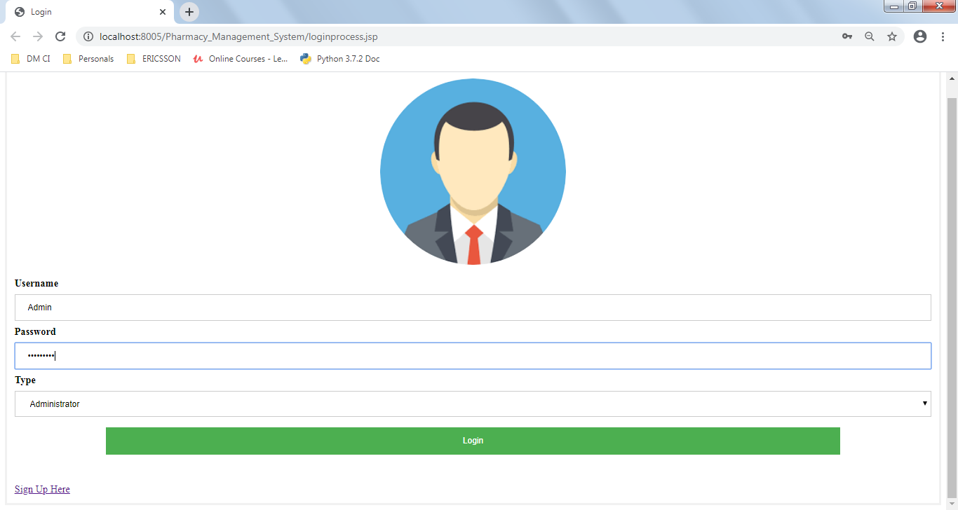

**Customer login:**

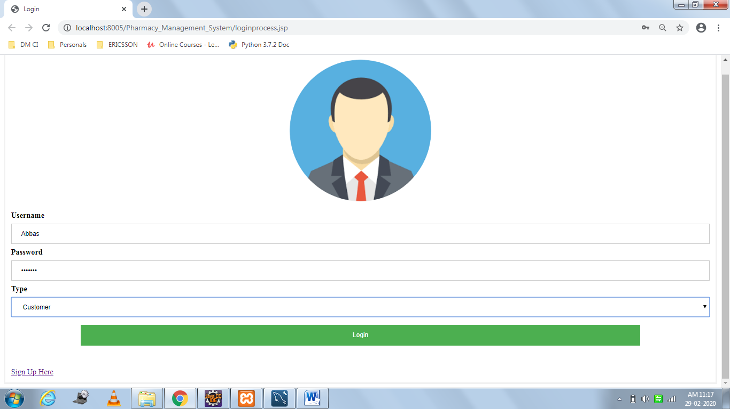

**Admin Page:**

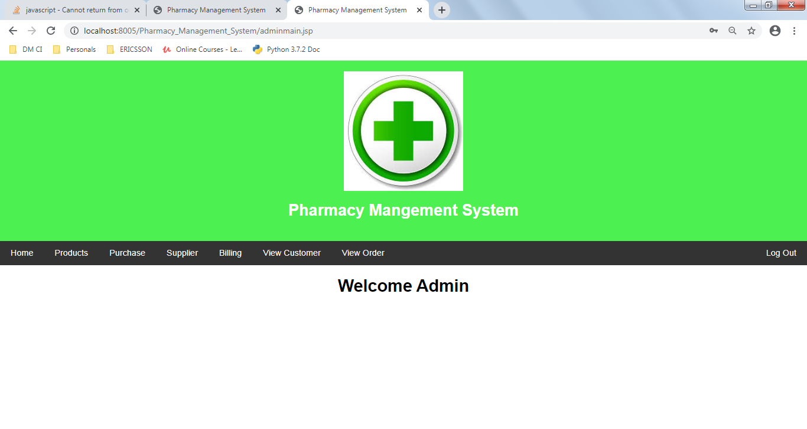

**Add Products:**

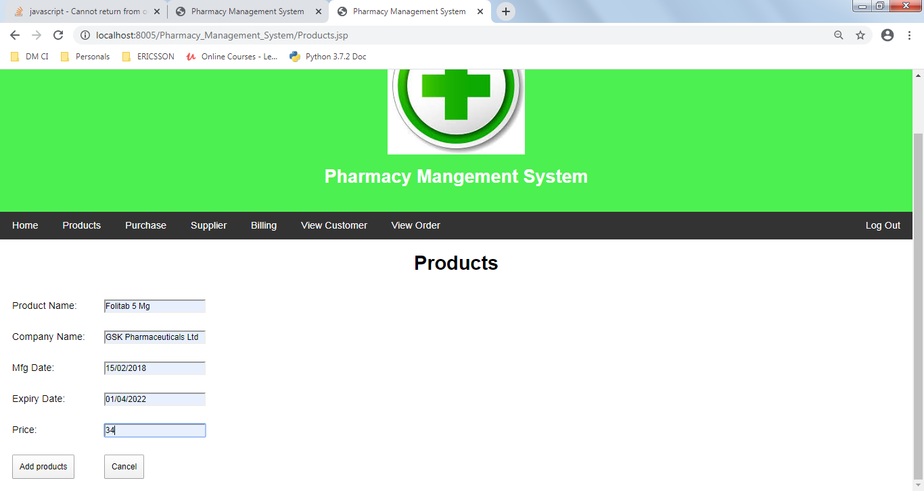

**Supplier:**

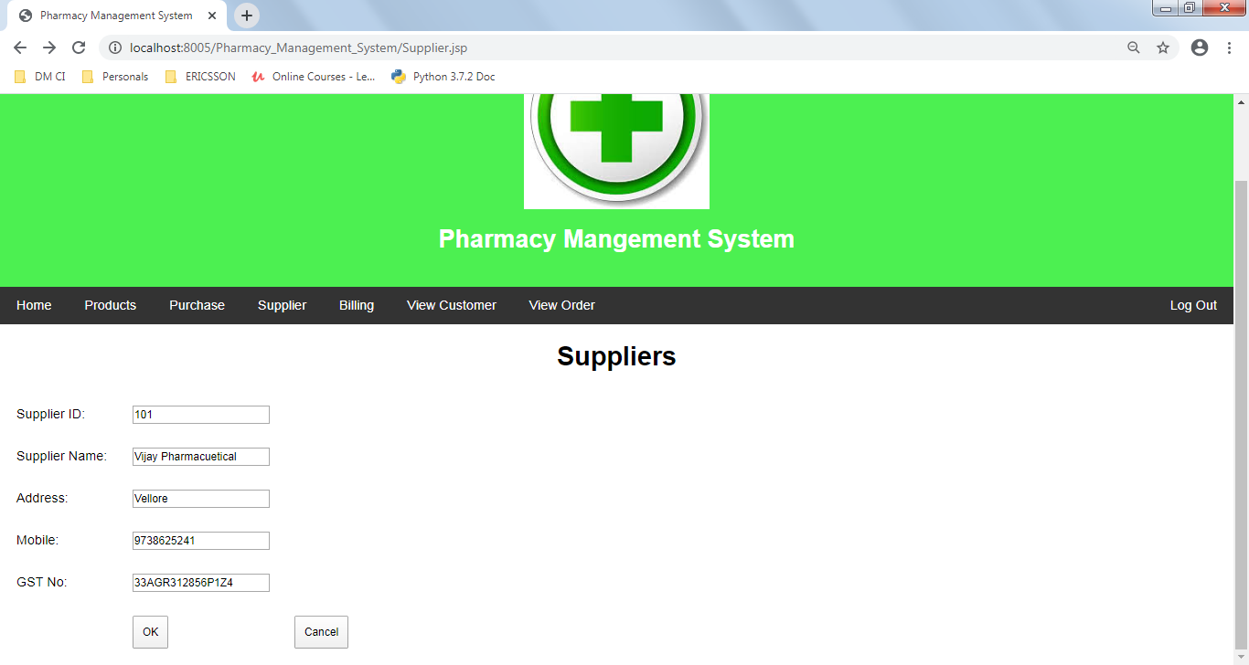

**Purchase:**

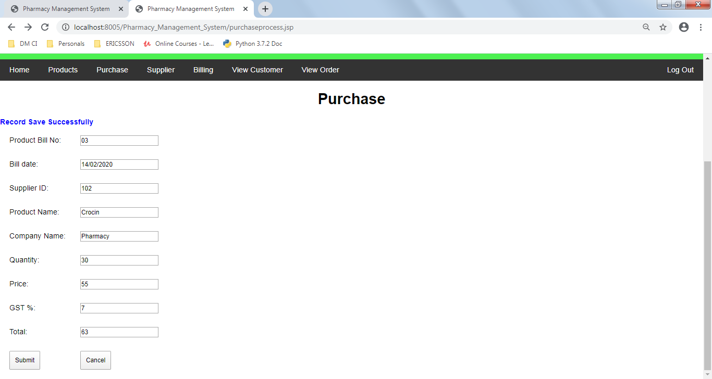

**Billing:**

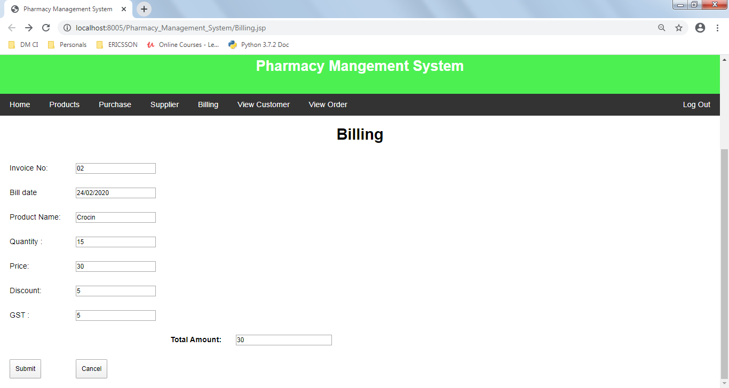

**View Customer:**

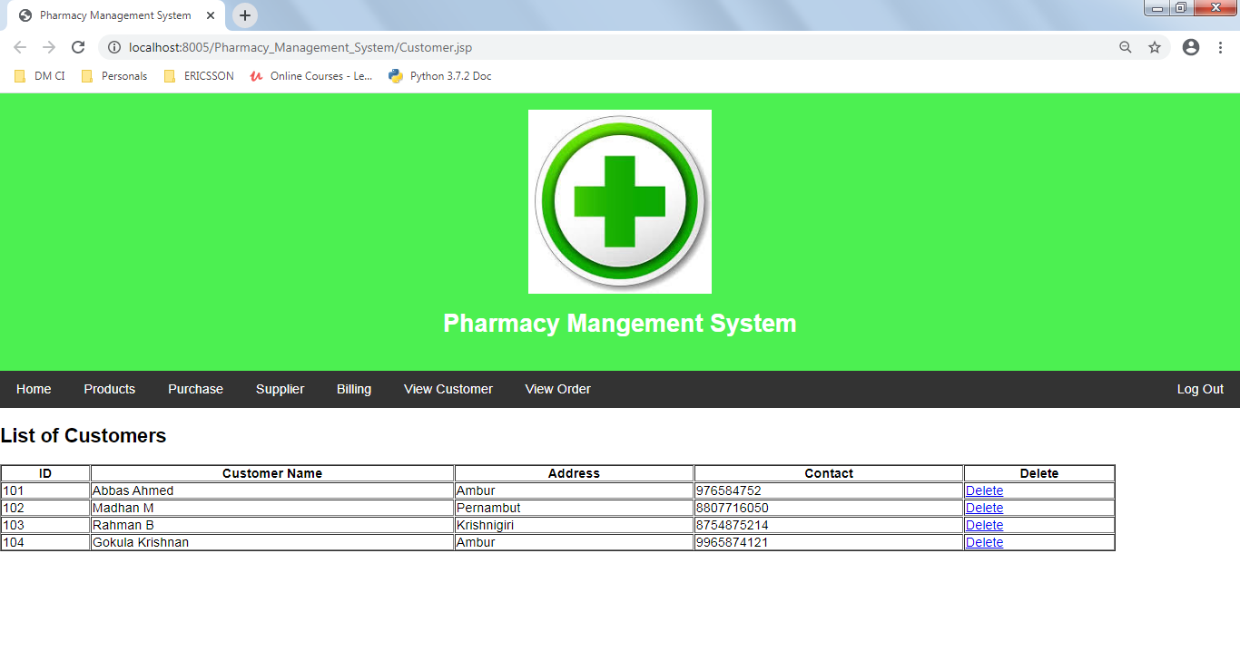

**View Orders:**

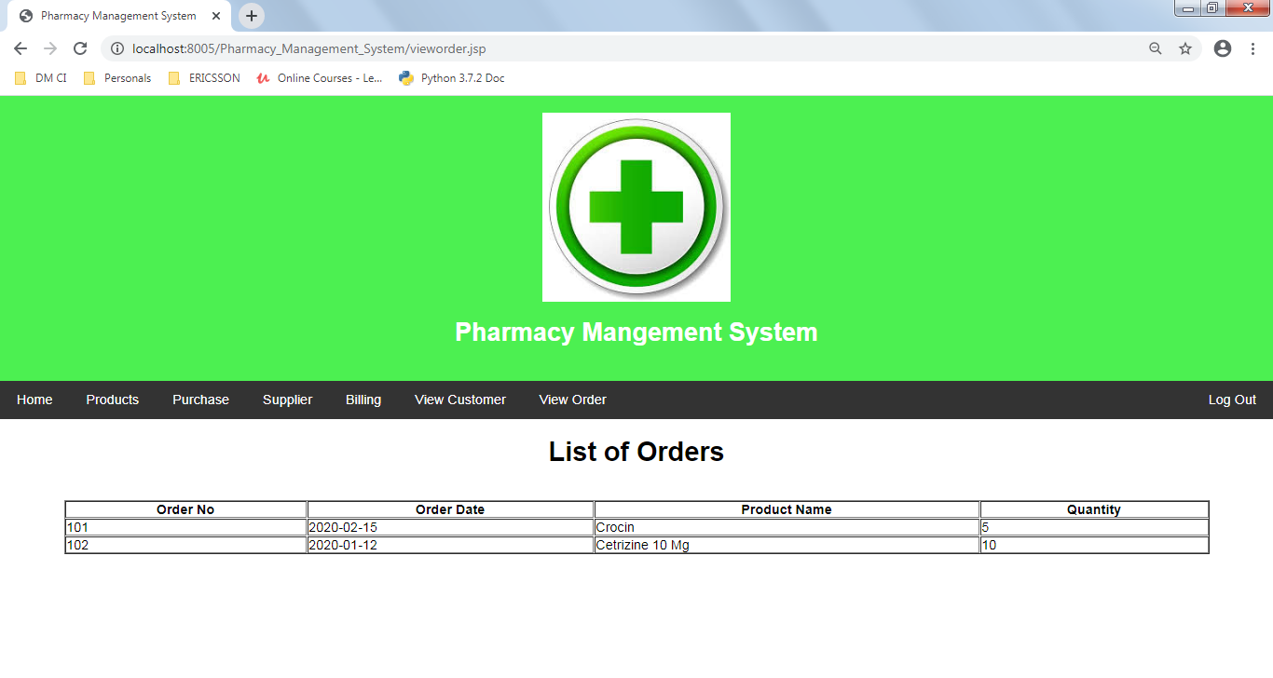

**Customer Main Page:**

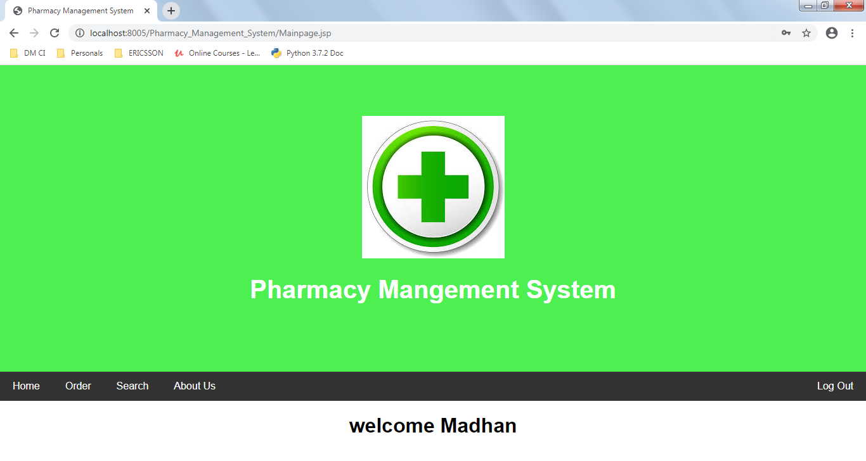

**Order Form:**

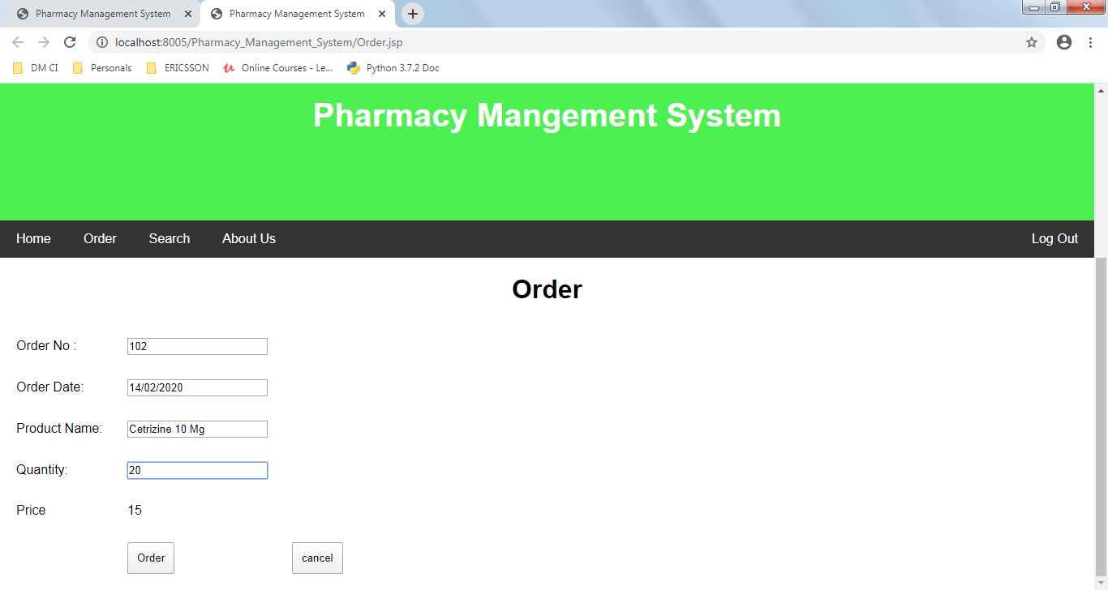

**Products Search:**

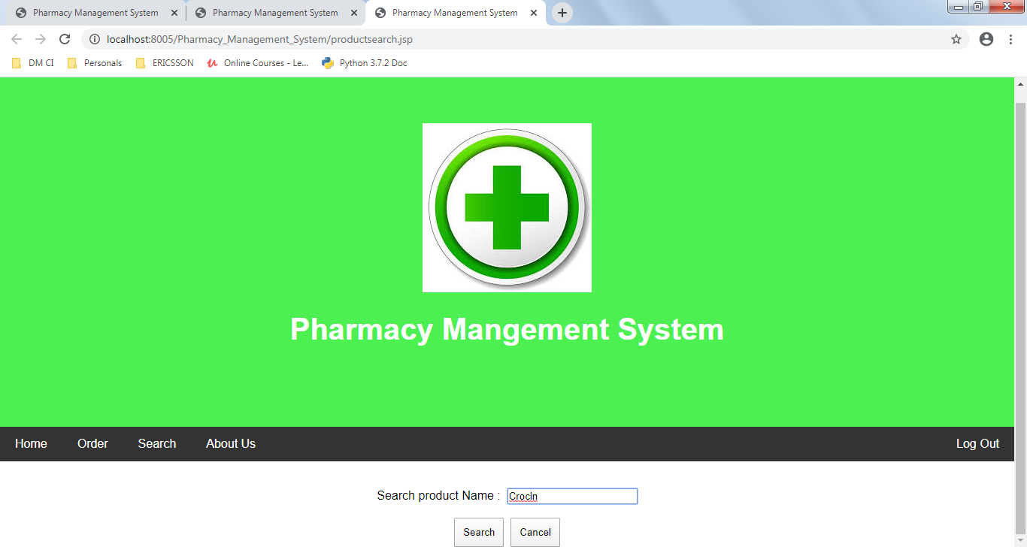

**Product List :**

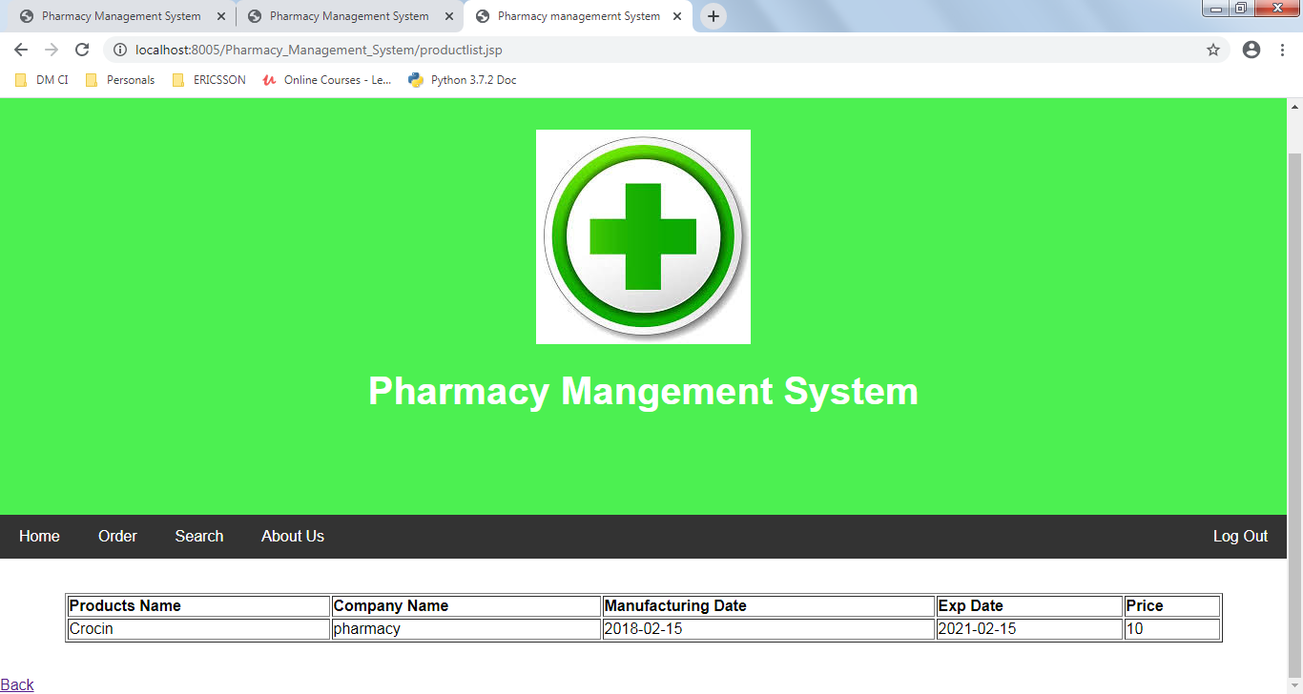

**About Us:**

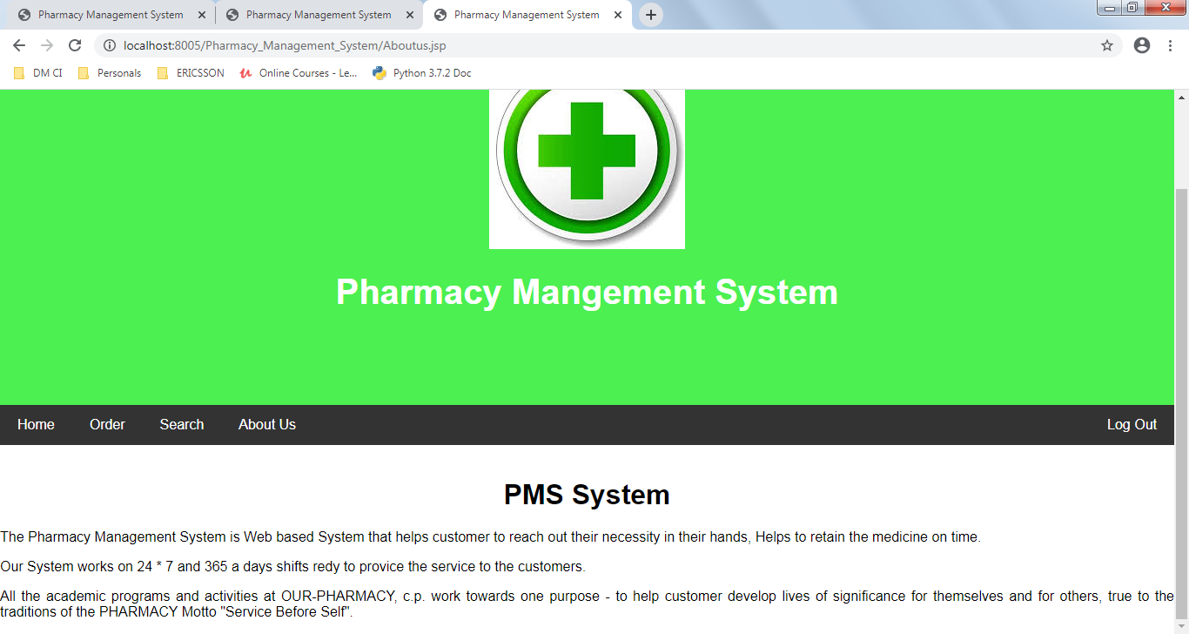

**CONCLUSION**

This Projects ”Pharmacy Management System” has been developed to provide and overcome the problem faced by the present system.The developed package was found to work out the operation in the present system. The developed package was found to work out the operation effectively. The objective was to reduce inconsistency, limiting redundancy , accessing data within less time to be achieved. It is user friendly, fast, secure and optimized. It helps to manage and provide more efficiency in work. This Projects is highly flexible for future addition and can adapt to any requirement.

**BIBLIOGRAPHY AND REFERENCES**

* Servlet and JSP Programming - By Uell Wahell, Mitch Fielding
* Core Servlet and Java Server Page - By Marty Hall , Larry Brown
* A beginner’s Tutorials Servlet and

JSP - By Budi Kurnia

**References:**

* A complete reference JSP - By Phill Hanna
* Tutorial Point - [www.tutorialpoint.com](http://www.tutorialpoint.com)
* Java Point - [www.javapoint.com](http://www.javapoint.com)
* W3School - [www.W3Schools.com](http://www.W3Schools.com)